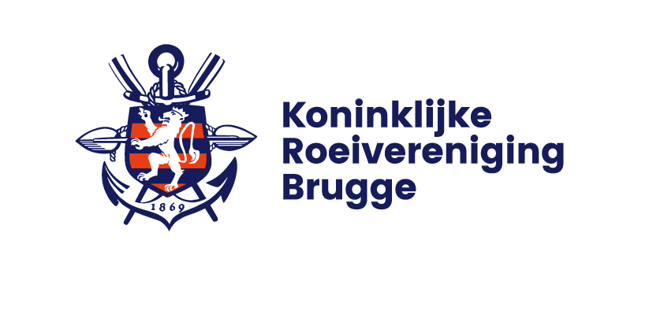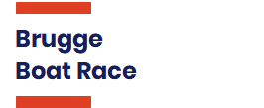

**BRUGGE BOAT RACE – 28th edition**

**Saturday 4 March 2023 & Sunday 5 March 2023**

**The Brugge Boat Race is an international rowing event over a 5000 meters race course on the Ostende-Bruges Canal between Nieuwege Bridge and the KRB Club House.**

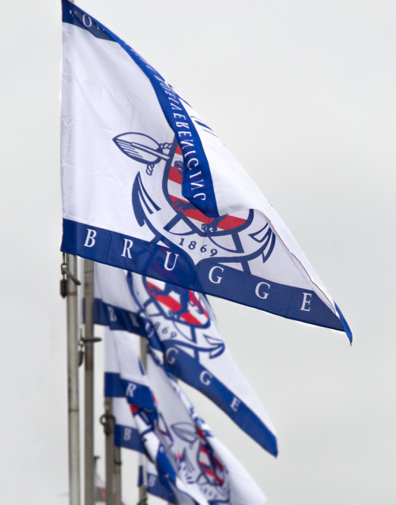

**On Saturday afternoon the boat race is exclusively for coxed eights. All categories (senior, junior , students , masters and tour rowers eights) compete in two heats. Every minute two boats start side-by-side.**

**Sunday morning’ head races are for all other types of boats with rolling starts at intervals of 15 seconds.**

**Registration deadline is Friday 17 February 2023 at 6:00pm   
(**[registration info](http://176.32.230.251/langerei.be/bruggeboatrace/?page_id=97)**)**

**This year’s 28th edition follows after a one year break due to the COVID pandemic which forced us to skip a year for this international event. In the last edition of the Brugge Boat Race no less than 74 eights took part in the boat race and a total of more than 1000 rowers from 7 European nations raced in all events of the weekend.**



**Type of Event**

* Saturday: Eights only Boat Race – 5Km – side-by-side starts
* Sunday: Head Race – 5Km - all other types of boats – individual starts

**Events offered**

* Seniors, Students and U19
* Masters and Mixed handicap races

**Website**

[www.bruggeboatrace.be](http://www.bruggeboatrace.be)

**Organising Committee**

Koninklijke Roeivereniging Brugge vzw  
[www.KRBrugge.be](http://www.KRBrugge.be)

**Contact Information**

Email: [info@bruggeboatrace.be](mailto:info@bruggeboatrace.be)  
Tel: +32 50 317 002  
Address: Waggelwater 4, BE-8200 St-Andries-Brugge, Belgium   
([Google Map](https://goo.gl/maps/zeFa9iHXiGu) link <https://goo.gl/maps/zeFa9iHXiGu>)

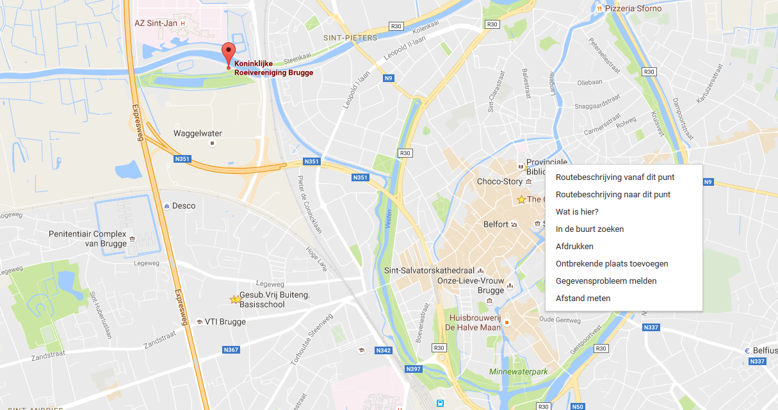

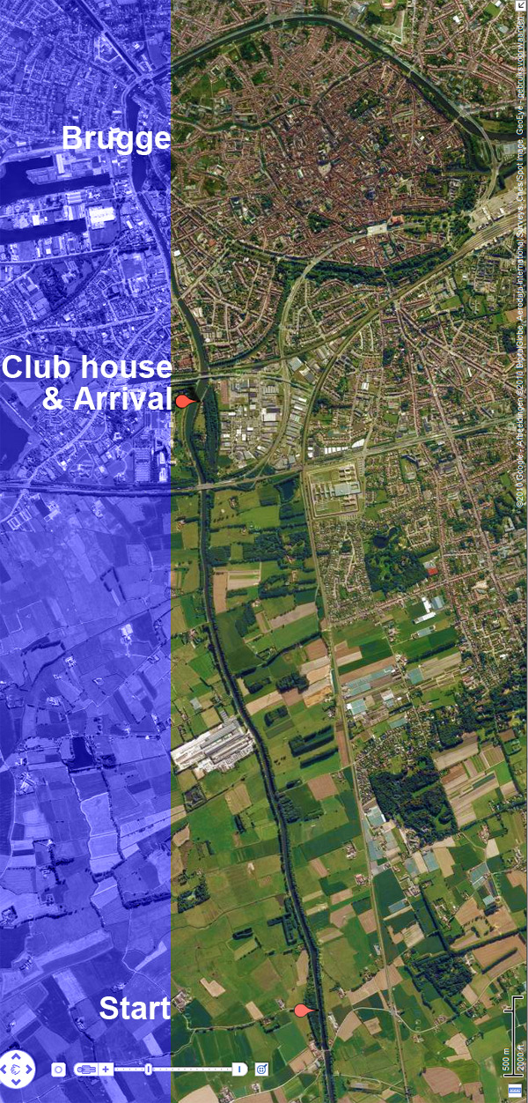

**Cooling Down**

**Safety post 1**

**Safety post 2**

**Lining up**